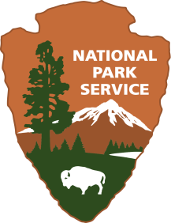
Pythagoras’ Kite
Wright Brothers National Memorial
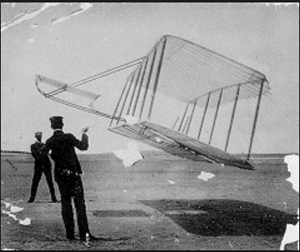
Location: On-site
Grade: 8th grade
Subject: Mathematics
Duration: 90 minutes
Key Vocabulary: Pythagorean theorem, right triangle, altitude, hypotenuse
North Carolina State Standards:
8.G.8: Apply the Pythagorean Theorem to find the distance between two points in a coordinate system.
Materials:
kite (provided by the Park Service)
tape measure
graph paper
pencil
Site Significance:
The Wright brothers’ realization of humanity’s age-old dream of powered, controlled flight at this site transformed our future and our perception of space and time.

Objectives: The student will be able to: a) identify parts of a right triangle, b) use the Pythagorean Theorem to find the distance between two points, c) understand what instruments the Wright brothers used to help them achieve first flight.
Essential Question: How could the use of the Pythagorean Theorem help to identify distances between two points?
Method: Students will visit various historic sites at the Wright Brothers National Memorial and identify ways that the Pythagorean Theorem can be used. They will utilize kites and various tools to help them as they complete each activity.
Background: The achievement of first flight by the Wright brothers in 1903, was in large part due to their ability to apply mathematical concepts and utilize them to help build and control the first flyer. During their first four successful flights, on December 17, 1903, one piece of information is still unknown today; the altitude of the flyer. Students will apply their knowledge of the Pythagorean Theorem in an attempt to discover the possible altitude of the 1903 Wright Flyer. They will also utilize the theorem to help determine the distance to the top of the memorial. Finally, they will explore the newly renovated visitor center at Wright Brothers National Memorial to learn more about the tools and instruments used during the famous flight in Kitty Hawk, North Carolina.

Suggested Procedure
Pre-Visit:
As a class, or in small groups, have students conduct background research about the time spent at Kitty Hawk, NC by the Wright brothers. The following websites provide valuable information about the tools and methods used during this time period:
https://www.nps.gov/wrbr/learn/historyculture/theroadtothefirstflight.htm
https://virginiatoolworks.com/tag/wright-brothers/
https://wright.nasa.gov/airplane/tunnel.html
Questions to consider:
- What tools did the Wright brothers use to help them build the 1903 flyer used at Kitty Hawk, NC to achieve first flight?
- How did the Wright brothers change their original design to help achieve “controlled” flight?
- What instruments were used on the 1903 flyer and on the ground to help document the achievement of first flight?

On-Site:
Students will disembark the bus and be divided into three different groups. Each student will have a partner that they will work with throughout their visit at the Wright Brothers National Memorial. Each group will start at a different activity and rotate approximately every 30 minutes.

Activity 1 (30 minutes): Each student pair will be given a kite, a pencil, two cones, and graph paper. Each pair will position one cone at the First Flight Boulder in a horizontal line. The second cone should be positioned horizontally from the 1st flight marker. Working together the students will begin flying their kite. Once the kite is in the air, Partner B will position themselves at the second cone, which is to be placed horizontally from the first marker from the boulder. Partner B will alert Partner A when the kite has reached the first marker. Partner A, holding the kite string will place a mark on the string, with a marker/pen, and bring the kite down. The partners will work together to then determine the length of the string, the distance between themselves, and then will apply the Pythagorean Theorem to determine the altitude of the kite.
Activity 2 (30 minutes): Students will climb the hill that the Wright Brothers Monument sits atop. Once they reach the top they will be given a tape measure, pencil, and graph paper. One partner will position themselves at the base of the monument and the other partner will choose a distance to stand away. Using the tape measure they will measure the distance from each other in feet. Using the height of the monument (60 ft) and their distance from each other, they will draw a right triangle and label the corresponding portions. They will them apply Pythagorean Theorem to determine the distance from the farthest partner and the top of the monument and label the triangle accordingly.
Activity 3 (30 minutes): Students will explore the newly renovated Visitors Center to learn more about the Wright brothers time at Kitty Hawk from 1900-1903. While touring the center students should look to identify how right triangles were used in the design and development of the 1903 flyer. Questions for students to consider while touring the Visitors Center:
- How many right triangles can you identify on the replica of the 1903 Flyer?
- How did the Wright brothers achievement of controlled flight impact the evolution of flight as depicted on the mural in the Visitors Center?
- How did Wilbur and Orville’s sister, Katherine Wright, help her brothers achieve first flight?

Post-Visit:
After the completion of the activities, students will analyze and compare their data with their classmates. As they compare data, students should determine how their calculations differ from each other and then compare and contrast the use of the various tools they used and the tools the Wright brothers used during their time at Kitty Hawk, North Carolina.

Evaluation Rubric:
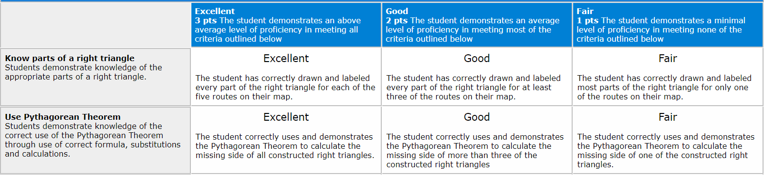
Concluding Questions:
- What challenges did you face when trying to calculate the altitude of the kite?
- What challenges did the Wright brothers face during their time at Kitty Hawk?
- Why is the use of the right triangle an integral part of the 1903 flyer design?

Extensions:
Culminating Activity: Have students create a blueprint of the 1903 Wright flyer on graph paper and identify the different right triangles used in the design.

Additional Resources
Websites:
https://www.nps.gov/wrbr/learn/historyculture/theroadtothefirstflight.htm
https://virginiatoolworks.com/tag/wright-brothers/
https://wright.nasa.gov/airplane/tunnel.html

Books:
Tom Crouch, First Flight: The Wright Brothers and the Invention of the Airplane

